
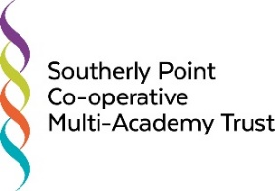

Southerly Point Co-operative Multi-Academy Trust
Standards Committee Meeting
Thursday 17th October 2019, from 6.00pm,
in the Trust Conference Room

Agenda

- Welcome and Declarations of Pecuniary Interests
- Minutes and Matters Arising
- Performance and Progress Data – Primary [RLa]
- Performance and Progress Data – Secondary [DBr]
- Behaviour and Attendance Data [DBr]
- Updates to Risk Register [DBr]
- AOB
- Dates and times of future meetings

