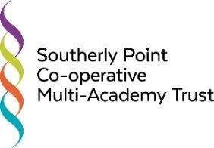


Southerly Point Co-operative Multi-Academy Trust
Finance and Resources Committee Meeting
Thursday 4th March 2021, from 6.00pm
Online meeting due to the Covid 19 pandemic

Agenda

Item | Purpose / Action | Timing [mins] | Who
Welcome and Declarations of Pecuniary interests | Review |  | Chair
Minutes and Matters Arising | Review | 10 | DBr
Estates Report | Information: Pre-read and come with questions / challenge | 10 | SPi
Compliance Schedule | Review | 10 | SPi
SCA Working Group | Information | 5 | SPi
Latest Management Accounts | Information: Pre-read and come with questions / challenge | 20 | SPi
Policies | Not applicable on this occasion | 0
Price of Living Rise Support Staff | Pre-read  Ratification required | 5 | SPi
Benching Marking | Information: Pre-read and come with questions / challenge | 15 | SPi
Updates to the Risk Register | Suggest / ratify any changes to the register | 15 | DBr
Any Other Business:  External / Internal Auditors  Cycle to Work Scheme | Information | 5 | Chair
Dates and times of future meetings | Information |  | Chair

